Ideation Phase
Define the Problem Statements

Date | 2 July 2026
Project Name | BOOK STORE
Maximum Marks | 2 Marks

Customer Problem Statement:

Customers face difficulties in finding, comparing, and purchasing books conveniently. They need a secure and easy-to-use online platform that provides book search, filtering, reviews, shopping cart, order tracking, and efficient bookstore management in one place.
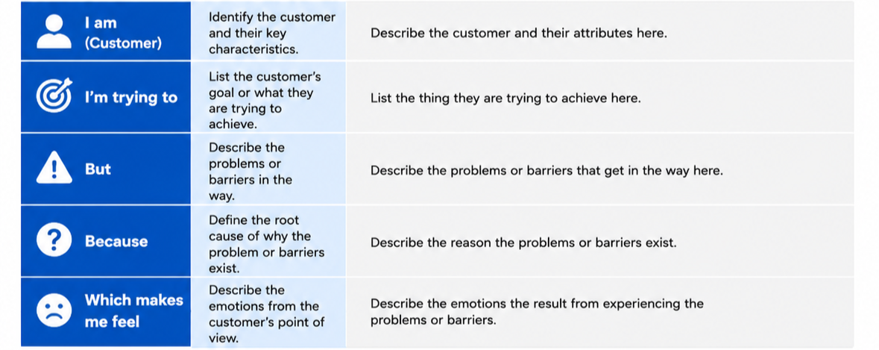
Reference: https://miro.com/templates/customer-problem-statement/
Example:
